CHAPTER ONE INTRODUCTION
The emergence of early antivirus software back in the 1980s sparked the birth of a new industry where early developers of third-party antivirus solutions such as McAfee and Norton first emerged as pioneers of the commercial antivirus industry. The “Brain” computer virus in 1986 which was the first computer virus targeted at IBM PCs pushed the development of anti-virus software to combat these threats (Echegu & Agwu, 2024).
The creation and widespread usage of the World Wide Web in the 1990s directly led to the emergence of more sophisticated viruses when compared to their predecessors. During this era, the creation of Macro viruses targeted computer software such as Microsoft Word to infect and spread via email attachment and caused significant damage by overwhelming email servers (Nilupul, 2024). Today, antivirus software has advanced in a way that it is now a complex, system integrated engine critical to protect the integrity of operating systems, securing important user data, and maintaining the operation stability of both enterprise and personal computing environments. Modern AVs now rely on deep system hooks such as the usage of Antimalware Scan Interface (AMSI) which is used by Microsoft Defender to enhance protection against fileless malware rather than relying on file signatures (chrisda, 2025).
The modern threat landscape has evolved beyond traditional file based exploits. A study by Ferdous (2023) highlighted a sharp rise in ransomware, cryptojacking and fileless malware which operates entirely in RAM alongside attacks targetting mobile devices, IoT networks and remote workers. This in turn causes AVs to use more aggressive and resource heavy behavioral monitoring in order to detect and block these threats as modern threats such as fileless malware leaves no traditional footprint. This rise in increasingly dangerous cyber-attacks means users have to be weary of their devices being hijacked, performance degradation and in the worst case scenario data theft and financial loss all without visible signs. With the most popular method of attack being phishing, everyday users are at risk of exposing themselves to these threats during their daily browsing.
However, as operating systems continue to develop, so do their built-in security services and protection features, for example, Microsoft Defender. With modern operating systems such as windows 11 offering a solid and capable built-in antivirus solution, the question arises whether there is still a need to replace Windows Defender with third party antivirus solutions (Delaney, 2020). Despite Microsoft Defender’s reputation as a reliable antivirus solution, a massive market for third-party antivirus software still exists. The availability of robust, free third party antivirus solutions presents a dilemma for modern computing users, does replacing the integrated Windows Defender with a free third party alternative offer superior behavioral detection and better performance? As stated by Baker (2018), achieving higher detection rates often incurs a performance tax as third party AVs deploy aggressive behavioral shields.
This dilemma forms the core purpose of this project which is to evaluate the true tradeoff between behavioral detection efficiency and system performance overhead. This project aims to benchmark the included Microsoft Defender against leading free third-party antivirus solutions in a Windows 10 environment. Therefore, a custom and modular AV Benchmark Testing Framework was developed. Unlike standard testing frameworks that are often blocked by an interpreter shield, this framework features an Adaptive Behavioral Anomaly Engine (ABAE) that hands raw payloads to system interfaces such as PowerShell. By executing a four layer testing stack ranging from static signatures to user layer phishing and advanced behavioral storms, the developed benchmark framework calculates a comprehensive physical score based on detection latency and hardware resource consumption. The results will them determine if the behavioral detection advantages of free third party engines justify their performance cost over native system defaults.

Background of Study
Microsoft Defender formerly known as Microsoft AntiSpyware was first released on October 24, 2006 and was launched as an anti-spyware tool for Windows XP and Windows Server 2003. Over time, it was developed into a full-fledged antivirus program and was completely implemented as Windows operating system built-in antivirus with Windows 8. It aimed to provide features such as real-time protection against malware and spyware as well as other known software that can potentially damage the operating system (Shinder, Diogenes, & Shinder, 2013).

On the other hand, third-party antivirus software has been offering real-time protection, prevention, performance enhancement, and safeguarding of data as early since its inception in the 1980s. Combined with the industry’s commitment of updating regularly to address new security issues, introduce new features, correct bugs and so on makes third-party antivirus software more enticing (Echegu & Agwu, 2024). These offerings of new features often claim superior malware detection capabilities, smarter threat intelligence and customization features that go beyond what built-in antivirus solutions typically provide.
Despite that, in a report by Cruz (2024) 40% of Americans specifically opt to use system default antivirus with the reasoning of not needing a third-party antivirus. Paired with the fact that 54% of Americans use system default antivirus, this shows a strong trust in the capabilities of the built-in antivirus in defending their system to the point where they do not feel the need to explore and try out a third-party antivirus.
While third-party antivirus software does offer advanced and up to date security features such as McAfee Total Protection providing anti-phishing capabilities and Norton Antivirus offering features such as identity theft protection, some users view these additions as unnecessary or excessive. The constant updates and bloatware that comes with the software makes it a hassle for users who rarely encounter security threats in their daily usage.
Moreover, concerns around data privacy have caused further skepticism. Cruz (2024) reported that many non-users have security concerns regarding the misuse of customer data as evidenced by Avast deceptive practices in collecting and selling detailed user browsing data to third parties. These factors acts as a significant barrier for casual users who may or may not need the additional features.
Therefore, based on the differences and user preferences, it can also be said that it is essential to evaluate antivirus software based on two core aspects, performance and detection. Performance refers to how efficiently the antivirus runs in the background of the system and its impact on the performance of system processes and resource usage. Detection is the software’s ability to accurately identify and respond to various types of malware while also minimizing false positives. These two core

aspects directly impact the overall effectiveness of an antivirus solution especially for everyday users who prioritize smooth system performance and reliable protection.
By objectively comparing antiviruses based on system performance and malware detection accuracy by using a lightweight and easy-to-use evaluation tool, it enables users to make informed and factual decisions based on their antivirus needs.

Problem Statement
As third-party antivirus solutions continue to develop and compete with an increasingly improved built-in antivirus solution such as Microsoft Defender, there remains uncertainty about which option offers more protection and efficiency. While the study conducted by Baker (2018) measured the impact of third-party antivirus software on the system performance compared to Microsoft Defender, the study did not test modern behavioral detection rates, which is an aspect this project focuses on.
While advanced benchmarking and antivirus testing platforms do exist, other open-source platforms are not modular and often specialize in only one aspect of testing. Furthermore, standard testing scripts fail to properly trigger stateful behavioral analysis due to interpreter interference, where the antivirus blocks the Python wrapper rather than evaluating the raw behavior. There should be a lightweight, modular software framework capable of combining all aspects of testing into one platform. The software should be backed by reliable tests conducted in a safe environment, calculating both detection latency and hardware resource consumption, to give the benchmark tool credibility in its comparison.

Project Aim
This project aims to answer the following questions.

PQ1: Are free third-party antivirus solutions better in terms of behavioral detection performance and system impact compared to built-in antivirus like Microsoft Defender?
PQ2: Are free third-party antivirus solutions still necessary in 2025 or does their hardware performance cost outweigh the benefits given the improvements in default operating system security?

PQ3: Can a lightweight, modular benchmarking tool be developed to objectively compare antivirus system performance and detection responsiveness against standardized, raw behavioral threat simulations?

Project Objectives
This project aims to achieve the following objectives.

PO1: To determine the difference in behavioral detection performance and system impact of free third-party antivirus solutions compared to Microsoft Defender in a Windows 10 environment.
PO2: To establish a 10 point scoring system that balances an antivirus engine’s detection success against its system resource consumption (CPU, RAM, and Disk I/O)

PO3: To develop a modular, Python based benchmarking framework capable of deploying multi-layer security tests and organizing results to a centralized remote server for comparative analysis.
PO4: To develop an Adaptive Behavioral Anomaly Engine (ABAE) that bypasses Python interpreter shields by handing raw payloads directly to system-level interfaces for accurate behavioral evaluation.

Project Scope
This project will provide a comprehensive analysis of built- in vs free third-party antivirus software. The report will cover antivirus technologies and types with the intention to clearly understand how different antiviruses differ in their behavioral detection techniques. This includes free third-party antivirus solutions and Microsoft Defender. Other areas of focus in this report will be performance indicators of antivirus software, benchmarking and comparative analysis methodologies and the limitations and challenges in assessing antivirus solutions and its security effectiveness.
The project will only cover free third-party antivirus products and will not cover enterprise or server-level or paid premium antivirus platforms. Usability testing, UI/UX evaluation and premium features are strictly excluded from this project. This project will also only focus on the Windows 10 operating system and not evaluate other platforms such as mobile platforms, Linux and macOS.
The benchmarking tool will be developed in Python and will only run on Windows 10. Its purpose is to automatically detect the current antivirus used by the system and present the user with a GUI that compares parameters such as detection rate, average detection time, CPU usage, memory usage and a total score out of 10. The tool will execute a four-layer testing stack in a safe environment. This includes using PowerShell commands to generate an EICAR file, simulating user-layer attacks via GoPhish, running Atomic Red Team tests offline, and executing raw payloads via the Adaptive Behavioral Anomaly Engine (ABAE). The framework will measure hardware resource usage, produce an overall score, store the information into a .txt file, and upload the dataset to a centralized remote server.
The benchmark tool will only be used on a controlled safe environment hosted on a personal homelab running the Proxmox hypervisor. The isolated network environment consists of a Windows 10 virtual machine for local framework execution and an Ubuntu server virtual machine to host the GoPhish campaigns and the central reporting database.

Target Audience
This project is targeted towards the following audience.

TA1: Security Researchers and Malware Analysts who require a modular, lightweight framework to objectively evaluate how modern antivirus engines respond to raw behavioral payloads, stateful anomalies and simulated zero-day threats.
TA2: System Administrators and IT Professionals who need to benchmark the hardware performance cost (CPU, RAM, Disk I/O) of free third-party antivirus solutions against native built-in protection when provisioning Windows environments.
TA3: Cybersecurity Students and Educators who seek a comprehensive, multi-layer testing environment to study antivirus mechanisms, execution handoffs, and system telemetry without requiring heavy enterprise simulation infrastructure.

Project Justification
This project aims to clearly compare free third-party antivirus solutions with the built-in antivirus solutions packaged together with the Windows 10 operating system. By doing so, it allows users and system administrators to make informed decisions regarding their usage of antiviruses. This project aims to inform users on how well their antivirus works by conducting a comparative analysis supported by a software tool designed to measure the behavioral detection and hardware performance of each antivirus in a controlled environment.
The significance of this project lies in its purpose to determine whether utilizing a free third-party antivirus software is strictly necessary given the modern improvements of native antivirus solutions. With many users relying on marketing claims or assumptions, there is a critical need for a data driven project into the real world behavioral effectiveness and hardware performance cost of these antivirus solutions.
The project contributes to the field by developing a unified, modular benchmarking framework. While there are other open source antivirus testing frameworks available, there is not one that is fully modular and combines all testing layers into a single platform. This framework aims to solve that limitation with its modular architecture making it significantly easier for researchers to add new test modules, custom behaviors or zero day payloads without needing to modify the core system.
Finally, the project dives deep into the performance and detection of current available antivirus solutions and further explores these aspects through the development of the Adaptive Behavioral Anomaly Engine (ABAE). By bypassing interpreter shields and handing raw payloads directly to system interfaces, the framework provides an accurate evaluation of modern antivirus behavior.

Project Timeline
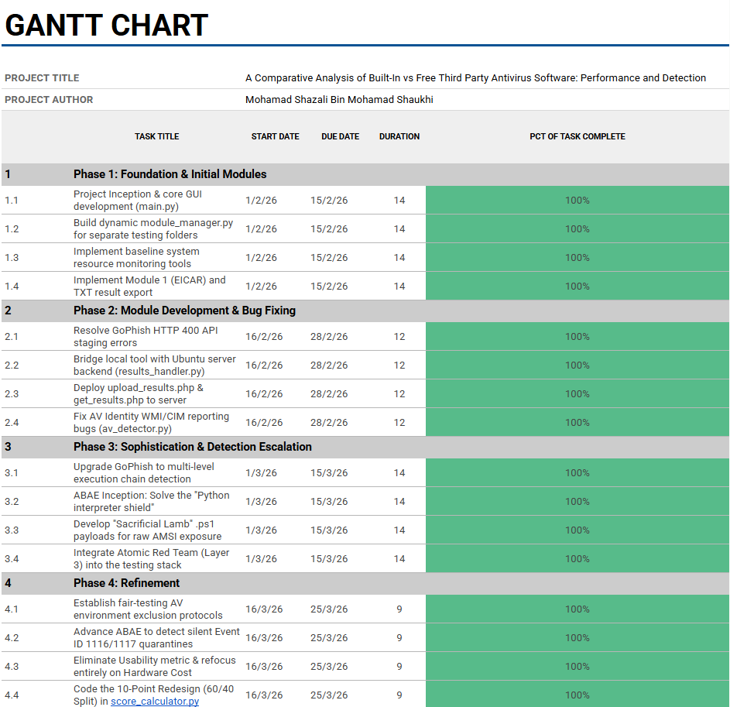
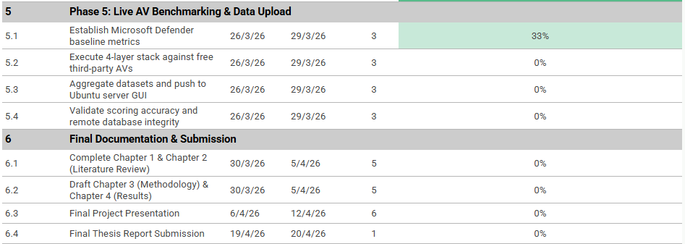

CHAPTER TWO

LITERATURE REVIEW

Introduction
A comprehensive review of existing literature is important in order to fully gauge and understand the capabilities of existing antivirus software and malware. To understand the evolution of malware and the improvements of antivirus software to combat such cyber threats, a thorough review of existing literature will give an insight on the development, evaluation and current capabilities of antivirus solutions in the context of combating cyber threats.
This chapter is organized thematically to cover key areas of antivirus software evaluation which include system performance, threat detection. However, before delving into reviewing the following studies, this chapter will first outline the theoretical frameworks that will support the study’s focus on cybersecurity effectiveness and hardware performance evaluation.

Theoretical Framework
The key theories and concepts this study draws from are several foundational models and frameworks relevant to cybersecurity architecture, anomaly detection, and systems performance evaluation. These include Behavioral Heuristics Theory, the Defense in Depth (DiD) model, and performance Benchmarking Theory, all of which have been widely used to explore the operational effectiveness of software solutions.
Behavioral Heuristics Theory provides insights on how modern antivirus transition from using static signature matching to dynamic, stateful analysis of execution patters which is needed in evaluating the raw payload handoffs in the Adaptive Behavioral Anomaly Engine (ABAE). In addition, the Defense in Depth model is used in order to understand the operating system’s layered security architecture while also giving context on how integrated solutions such as Microsoft Defender operate within the native environment compared to the kernel level hooks used by free third party alternatives.
Furthermore, Performance Benchmarking Theory provides a structured base for measuring the operational impact of antivirus software on system resources, such as CPU usage, memory consumption, and detection responsiveness.
These theories assist the research by providing a structured view through which the project’s core questions related to performance and behavioral detection can be examined and studied. By applying these theoretical frameworks, the study aims to explore whether free third-party antivirus solutions still offer benefits over Microsoft Defender in 2025, ensuring that the analysis is grounded in established perspectives and informed by previous research in both system engineering and cybersecurity benchmarking.

Review of Related Works
Each of the selected studies will be reviewed based on the following category that has been assigned to each one. The Effectiveness of Antivirus Software by Jeffrey Delaney (2020) will be carried out focusing on the study's elaboration on malware detection effectiveness. The Necessity of Third-Party Antivirus Software by Erik Baker (2018) studied the impact of antivirus software on system performance in depth, therefore, a review will be done focusing on that aspect. Lastly, From Origins to Future Trends by Arinze Darlington Echegu (2024) and other relevant literature works will be reviewed to study the historical evolution and future trajectories of antivirus technologies.

Malware Detection Effectiveness
Based on the research conducted by Delaney (2020), various detection techniques were examined that were used by antivirus solutions. Signature-based detection was discovered to only be effective against known cyber threats, while on the other hand heuristic methods and behavioral analysis aimed to overcome that limitation and adapt to new threats. Although heuristic detection is able to spot unknown threats, it also tends to trigger false positives whereas behavioral detection only observes software activity in order to identify suspicious or unusual pattern behavior making it more effective against malware that is stealthy. Another thing that was noted in the study was that the emergence of next generation antivirus (NGAV) utilizes a real-time endpoint monitoring and AI-driven models to assist with detection and response.
In a real world environment test, the study showed that only half out of the 30 antivirus products tested by AV-Comparatives met the minimum 98% detection rate which indicates that many antivirus solutions are not up to standard. The study also focused on Windows Defender with it showing strong results in zero-day protection especially since it applies NGAV technology however, it was also found that it still lagged behind other top tier products in areas such as adware detection. The conclusion of the study was that antivirus tools are still relevant but has to constantly evolve to keep up with modern cyber threats. These findings further prove the necessity of further evaluating the comparative strength of built-in solutions like Windows Defender.

System Performance Impact
Installing a third party antivirus solution would affect systems performance as having an always running program in the background of the system is bound to affect system resources. In the study conducted by Baker (2018), it was shown that using third party antivirus solutions in an offline environment had minimal impact on system performance, moreover it was discovered that third party antivirus solutions had a positive impact in systems performance particularly when it came to loading and saving documents. In the study it was concluded that based on the context of system performance, in a Windows 10 environment a third-party antivirus solution allows certain tasks to go faster by a few seconds despite having multiple detection methods running in the background. This highlights the importance of comparing and measuring performance tradeoffs especially in the context of non-technical users choosing between free and paid antivirus.

Classification of Antivirus Software

To further define and separate built-in and third-party antivirus, the following table summarizes their technical differences across key differences that are relevant.

Feature | Built-in | Third-Party AV
Default Installation | Yes | No
Price | Free | Free
Real-Time Protection | Yes | Yes
Ransomware Protection | Limited | Yes
Firewall Protection | Yes | Yes
System Resource Usage | Low - Medium | Medium – High (Varies)

The following classification table in 2.3.3 was based on comparative insights drawn from the previously mentioned and reviewed literature and general product documentation. The studies reviewed will directly influence the benchmarking process and evaluation criteria in the following chapters, guiding both the technical assessment and user-centered comparison of antivirus performance.

Existing Benchmarking Tools

In addition to academic literature, there exists independent organizations such as AV-Comparatives, AV-Test and SE Labs which conducts large-scale antivirus benchmarking. For example, AV-Comparatives recently published a report regarding Real-World Protection Test (February – May 2025) which assessed 19 consumer security solutions and evaluating their protection performance under realistic conditions which included malicious URLs, downloads and zero day threats which produced a result of Bitdefender achieving the top protection rate of 99.8% while Microsoft Defender managed to produce a protection rate of 99.1% (AV-Comparatives, 2025). This real-world benchmarking underlines that built-in antivirus capabilities have dramatically improved and can compete with third party antivirus solutions. However, these tests focus on purely on technical aspects of antiviruses and largely ignore usability factors. Another thing to consider is that the testing methods is not made available to the public and is only defined in the report. Thus, while independent organizations such as AV-Comparatives establishes industry-standard baselines, this project differentiates itself by combining detection metrics with usability and performance trade-off analysis while ensuring its transparent and open source tailoring to everyday users choosing between built-ion and third party antivirus solutions.

Critical Analysis of Existing Literature

The studies reviewed have significantly produced results that have contributed to the understanding of antivirus in terms of detection capabilities, system performance and user perception. Delaney (2020) study provided a comprehensive evaluation of malware detection effectiveness by drawing from sources such as AV-comparatives. The study highlighted that while traditional signature-based detection remains in use by antivirus solution, its limitation against the ever growing threat of cyber threats has pushed antivirus companies to pursue the adoption of next- gen AI-based detection methods. The study excels in highlighting the constant evolution of malware and the necessity for dynamic antivirus responses however, while it is informative it falls short in addressing the practical usability and applicability of antivirus software for everyday users. The study weakness can be seen in its dependence on lab-controlled AV-Comparatives which
while it provides sufficient context for IT professionals or organization, it lacks on providing sufficient analysis on user interaction and overall system usability.
The study conducted by Baker (2018) on the other hand, analyzes how third-party antivirus software affects system performance while in the background. Contrary to common belief, the result of the study suggested that certain third-party antivirus actually enhance task efficiency under specific conditions such as offline usage. The gap in the study can be seen in its lack of detailed hardware or sample size information which limits applicability and its complete omission of detection capabilities of antivirus solutions with the study putting more focus on only system performance impact.
In the research conducted by Echegu and Agwu (2024), the detailed breakdown on how malware evolves, adapts and bypasses traditional detection mechanisms such as signature based detection. The research goes in depth on advanced methods like sandboxing and behavioral analytics and puts a strong emphasis on malware behavior and the capabilities of modern protection techniques however, it offers very little discussion on how these advancements translate to actual improvements for the everyday users. It does not explore the usability or accessibility of these technologies for non-technical users who are often the primary targets of malware campaign. Combined, these studies reflect a broader trend where built-in antivirus solutions have significantly improved making it close the performance and detection gap with a majority of third party antivirus. However as stated before, third-party antivirus continues to differentiate themselves through premium features which built-in antivirus may or may not have. Despite each literature’s strength, none of them directly compares the real-world performance and usability of built-in antivirus and third party antivirus especially from the perspective of an non-technical user.
Consequently, these studies while insightful do not fully focus on users who are often the main victims of cyber threats and are also the main consumers of antivirus software. This research aims to fill these gaps by focusing on third party antivirus software relevance to non-technical users with the existence of a capable built-in antivirus solution such as Microsoft Defender.
While it has been established that antivirus software uses signature based detection to counter cyber threats, its inability to detect and respond to new threats in real time pushed the industry to evolve and develop NGAV. Organizations such as IBM, Microsoft and Threatdown has steadily implement NGAV into their antivirus solutions to further improve their defenses against cyber threats. The main advantage of using NGAV is that it does not rely on malware signature but rather it uses machine learning, behavioral analytics and exploit prevention to fight against malware in real time (Lindemulder & Forrest, 2023). Aside from that, many NGAV systems now utilize cloud based techniques to provide real time detection updates and reduce local system impact. For example, Microsoft utilizes NGAV in their Microsoft Defender for Endpoint offering key features such as Endpoint Detection and Response (EDR) which continuously monitors device activity and detects suspicious behaviors in real time (denisebmsft, 2025). While Microsoft has steadily updated their Microsoft Defender with NGAV technology, other third-party solutions such as Norton has also adopted similar improvements into their antivirus solutions often packaged as premium features. This key difference highlights different priorities in accessibility, pricing models and user target groups.
Despite all the advanced features NGAV has to offer, it has several significant challenges especially for the average user. NGAV uses more resources compared to traditional antivirus solutions which might not be worth the trouble for everyday users and on top of that it is still not a foolproof solution to combatting malware. NGAV technology should be used as a supplement alongside other antivirus technology as even NGAV cannot produce a 100% success rate without raising false positives and failing to detect a virus. Therefore, its real world effectiveness still hinges on how well it balances security with usability and system performance.

Summary of Findings and Research Gaps
The literature reviewed has established that antivirus software continues to hold a critical role in protecting users from cyber threats. Studies such as Delaney (2020) have proven that some third party antivirus solutions still offer strong detection capabilities due to their advanced features like machine learning. Additionally, the study done by Baker (2018) has shown that third party
antivirus software can actually further improve system performance in tasks such as file loading. Lastly, Echegu and Agwu (2024) reported that user awareness and usability directly impacted the overall effectiveness of antivirus solutions.
However, there are still gaps and questions that remain unanswered when reviewing the following studies. For example, Delaney (2020) comprehensively reviewed and evaluated detection methods of antivirus solutions and the performance of Microsoft Defender, but the study does not explore how non-technical users perceive its usability or whether its limitations justify purchasing third- party solutions for everyday needs. Echegu and Agwu (2024) did not focus on the role of antivirus software protecting everyday users who are most often the main target of malware attacks. Baker (2018) only focused on benchmarking the effects of third party antivirus software on system performance and did not run benchmarks or evaluate it based on factors such as usability and detection rate. These limitations highlight the need for further research that not only compares antivirus effectiveness but evaluates practical usability and relevance for day to day users.
Therefore, it can be established that there is a significant lack of research that benchmarks built-in and third-party antivirus software in a single framework focusing on both aspects of system performance impact and malware detection capabilities especially from the perspective of a casual and non-technical user. Furthermore, time has significantly passed that may change the results of their findings due to how fast technology develops. 5 years is plenty of time for built in antivirus to improve their performance. This project will seek to address these gaps by providing an analysis on both built-in antivirus solutions and third party using custom testing and structured evaluation criteria tailored to both technical performance and end-user experience

